**Airplane mode**

**Poster text**

**G.20105**

**Semester 2**

**2021-2022**

إإإإإإ

Abstract

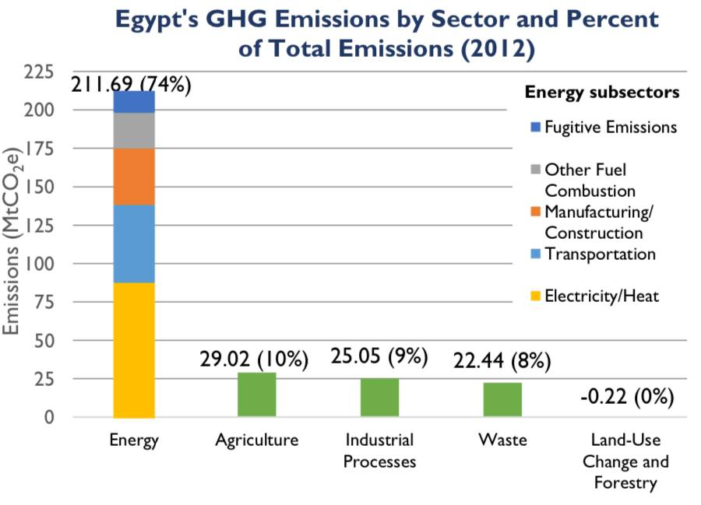Have you ever thought about how we can solve the increase of greenhouse gases in the atmosphere? Well, as we all know this is one of the most important challenges that face the entire world and must be solved as it can affect people's lives. The largest source of greenhouse gas emissions in the world

Graph 1

now is burning fossil fuels for electricity, heat, and transportation. Emissions of GHG in Egypt grew 133% from 1990-2012, this emission is mainly responsible for 41%, transportation 24%, manufacturing and construction 17%, other fuel combustion 11%, and fugitive emissions 7% of energy sector GHG emissions (as illustrated on graph 1).These emissions of GHG act like a blanket wrapped around the Earth, trapping the sun's heat and raising the temperatures. These dilemmas might ominously affect our prospective future if it is not solved. We tried to solve this challenge by using these gases and emitting energy from them. Our solution consists mainly of getting rid of the greenhouse gases by utilizing their effect of trapping heat from the infrared radiation, this heat will be transported by aluminum (a good heat conductor), and it will produce mechanical energy using the difference in temperatures in the prototype that we are building. Our solution appeared to be very efficient and it met the design requirements chosen. Finally, we could design an efficient solution that can help in facing the pollution and climate change challenges.

Introduction

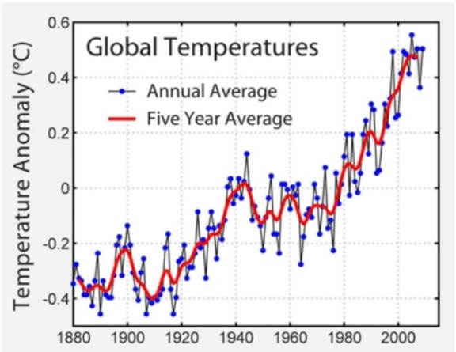"Quality is never an accident, it is always the result of intelligent effort“. Egypt has many challenges to overcome. Egypt suffers from many problems that have arisen with the development of science and technology. One of them is pollution. Pollution taints air and water with poisonous substances and impures them to the point that they become harmful to human beings, animals, and all living things. Egypt has air pollution, water pollution, and soil pollution. Recently, air pollution has caused climate change. Climate change is a change in patterns of weather and temperature. This change may be natural but since the 1800s, human influences have been the main driver of climate change, due to burning fossil fuels which generate greenhouse gas emissions (CO 2), (CH 4), (NO 2), and (CFCs) that trap the sun heat and raise the temperatures

**Graph 2**

(as shown in graph 2). Climate change may cause melting ice, rising seas, risks to human health, and risks to wildlife. There are many solutions had been already tried to solve this problem and provide the consequences of them and for example (the thermoelectric generator) The thermoelectric is two different metals joined together by a junction, one side is heated and the other is cooled creating a difference in temperature, which consequently produces voltage used in producing electrical current. After all these tried solutions we thought about our solution to solve the climate change challenge. Our solution depends fundamentally on trapping heat from the infrared radiation by greenhouse gases, then transporting it by aluminum, Heat transported will cause a piston to move up and down causing a flywheel to rotate producing mechanical energy. To become successful, the physical structure of our prototype must meet the following design requirements:

We are not allowed to integrate any electronic devices or circuits into our prototype structure.

*Applicative*: It should be made from local materials that are available in Egypt.

*Efficiency*: Our prototype should have good efficiency.

*Eco-friendly*: it should not affect the environment.

For building our prototype we wore gloves and followed the safety rules, we got a Pyrex container, a piece of aluminum, a base of wood, and two wood stands, then stacked them together, and we made a hole in the aluminum piece to get the greenhouse gases in the container. We put hydrogen in the cylinder and then secured the cylinder with a stand and the flywheel with another stand. We fixed the wood pistons. Sticking the aluminum piece with the cylinder. The prototype is ready to test. We tested it and the results were very effective.

Materials

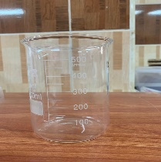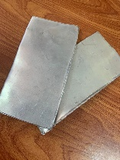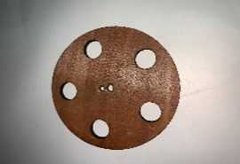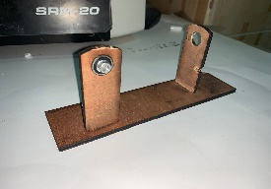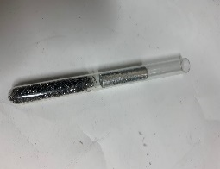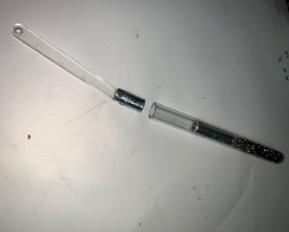

**100 L.E**

**93 L.E**

**Cylinder**

**Aluminum pieces**

**Wooden base**

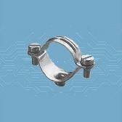

**Avis**

**40 L.E**

**Silicon**

**Container 550 ml.**

**27 L.E**

**2 aluminum pistons**

**Wooden flywheel**

Methods

* First, we got the dimensions of each component of the prototype and made the design on a solid works program.
* Wood parts were made with carpentry tools.
* We fixed one of the supports with the base. Then we fixed the cylinder made of Pyrex with the cylinder mount and connected it with the support by nails.
* We connected the tip of the cylinder by the hose.
* After that, we got a connecting rod and connected them to the cylinder on one end by the piston-mount parts, which are connected to the flywheel.
* We had put a fluid (helium) in the cylinder.
* We have put a heat source as a simulation to the solar collector, as it is not available. We had searched about the range of temperature the solar collector provides to know which heat source to use for the simulation, and the range was (140 F – 180 F ), so we decided to use a heat source of 75 C ( the flames provided in the school labs).

d

Test plan

After finishing our prototype, we started to plan to test it to check if it achieves our design requirements or not.

*The tools used:-*

* Source of heat (solar collectors with the shape of parabola).
* Table.
* Stop watch.
* Calculator.
* Fluid (helium).

*The steps and procedures that we have decided to follow:-*

* Put our prototype in a sunny place on it.
* Direct the solar collector to the cylinder (the cylinder must be in the focus of the solar collector).
* Wait some minutes until the piston is about to move, turn the stopwatch on, and also start to count the rounds that the rotator makes during a specific period of time.
* Calculate the angular velocity of the rotator during that time and write down the results.
* Calculate the mechanical energy by using the law of:½* I * ω²

I is the moment of inertia. ω is the angular velocity.

*Observation:*

 We used helium as we searched for the most effective fluids that function in the thermal processes, we found that the most common ones are helium and hydrogen. We saw a practical attempt for using them both and there was a graph that represents each one of them.

The x-axis presents the independent variable which is time, and the y axis represents the number of watts produced from the mechanical energy using a generator.

Result

After we have done the test plan, we achieved some results as illustrated in the table:

|  |  |
| --- | --- |
| Results | |
| ½mR2= 10-3 kg.m2. | Moment of inertia. (I) |
| 2 $π$ n = 81.71 rad/sec. | Angular velocity.(ω) |
| ½*I*ω² =3.34 joule. | Mechanical energy. |

When we tested the prototype, and the radius of its flywheel was small, it made the moment of inertia smaller, which will reduce the mechanical energy, in turn small efficiency. We made another flywheel with bigger radius, it was 5cm and we doubled it to 10cm.

Amount of gas

Analysis

The technology of using pistons to produce mechanical energy, is now becoming a very successful system, as it has no negative effects on the environment, it is easy to be applicative and has efficiency with a very low cost. Our prototype consists mainly of two parts.

* The first part is the Pyrex container that traps the heat with the help of a solar collector. In this process we will use aluminum to transport the heat to the piston.
* 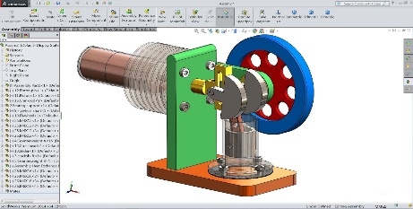The second part will be using this heat that cause the piston to move in and out , rotating the flywheel and producing mechanical energy.

Our system of the piston consists of:

* Fly wheel and base made of wood, one aluminum piston and one aluminum displacer, Pyrex tube and a simple heat exchanger. This can be illustrated on [figure 5].

Figure 5

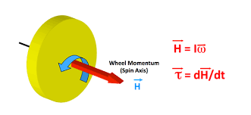After finishing its application the moment of its test came to check if it achieves our design requirements. We put our prototype and used a flame which is considered a simulation of solar collector, we have trapped a concentrated amount of car exhaust gases. We have chosen aluminum to transport the heat to our tube

Figure 6

Which contain the pistons. We waited until the piston was about, using a stop watch we have counted the revolutions that the rotator [6] makes during a specific period of time. In that moment we could calculate the angular velocity which can be defined as how much our wheel can rotate. The angular velocity is defined as how fast an object is rotating. To calculate the angular velocity, we have to calculate the angular displacement, the angular displacement is equal to ∆s/r

S: the arc length. ∆

r: radius. ∆

The angular velocity is equal to ∆ѳ/t

∆ѳ: angular displacement.

t:is the time.

As the flywheel will complete a whole rotation more than one time so the final equation is;

n ω= ѳ/t=2π

The periodic time is equal to 1/n which is the no of revolution and the theta is equal to 2π

ω= ѳ/t=2 $πn. It was 81.71 rad per sec.$

To calculate the mechanical energy we used the law of:

*½I* ω ².

I: is the moment of inertia.

ω: angular velocity.

We also calculated the efficiency of the Carnot cycle: 1-tc/th, in which (Tc) is the temperature of cooling and (Th) is temperature of heating. Our efficiency was 66.67%.

*Other laws used:*

* Conversion between temperature units.

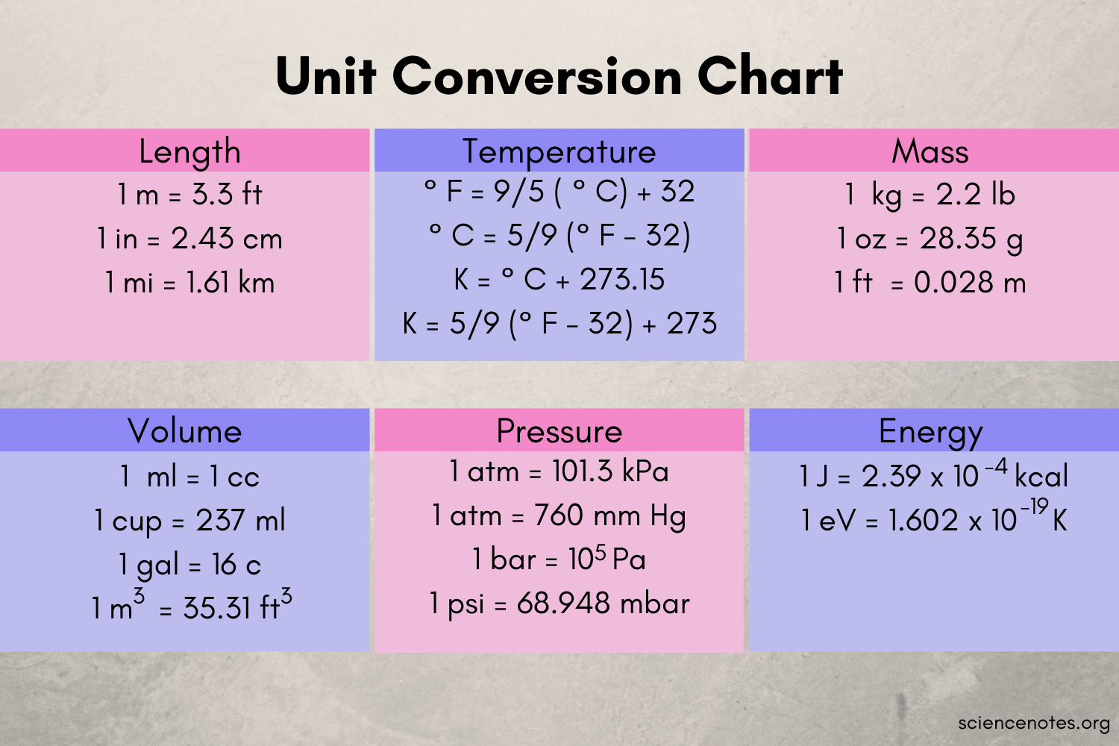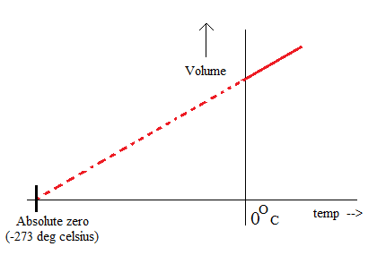Conversion between different temperature units has been a significant part of the project, as we searched for various temperature constants, For Instance: the range of temperature can a solar collector give, the temperature that moves the piston, etc…. Through this search, the results was with different units such as: kelvin, Fahrenheit and Celsius. Celsius is the most common unit, but it isn't the SI unit. The SI unit is the kelvin because it is the one that has the absolute zero (there is no smaller temperature).

Figure 7

The graph illustrates the reason why Celsius isn't a SI unit

conversion between temperature units

* The Carnot cycle.

The Carnot cycle is the scientific idea of our project:

1. Isothermal expansion. The expansion-space and associated heat exchanger are maintained at a constant high temperature, and the helium undergoes near isothermal expansion absorbing heat from the hot source.
2. Constant-volume (isovolumetric or isochoric) heat-removal. The gas is passed through the regenerator, where it cools, transferring heat to the regenerator for use in the next cycle.
3. Isothermal compression. The compression space and associated heat exchanger are maintained at a constant low temperature so the gas undergoes near isothermal compression rejecting heat to the cold sink.

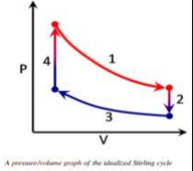4-Constant-volume (isovolumetric or isochoric) heat-addition. The gas passes back through the regenerator where it recovers.

 The moment of inertia is calculated by: ½mR²

m: is the mass of the flywheel.

R: is the radius of the flywheel.

Learning transfer

|  |  |
| --- | --- |
| **We studied how the human-caused events and the natural phenomenon have a huge role in the balance of the ecosystem.** | BI.1.14**.** |
| **We studied different gas laws, the concept of an ideal gas, and the different cases they are used in.** | CH.1.16. |
| **We studied the different resources used by different countries to meet their energy needs.**    **We studied renewable energy resources as a replacement for fossil fuels.** | ES.1.09.      ES.1.10. |
| **In these 2 Los, we learned about heat &thermal energy and thermodynamic processes(isothermal, isobaric, isovolumetric, adiabatic)** | PH.1.10, 11 |
| **We studied circular and rotational motion, and how to calculate the angular velocity and thus mechanical energy.** | ME.1.09. |
| **We studied the logarithmic and the exponential functions and how to represent data using them.** | MA.1.08. |

Conclusion

As shown in the results of the test plan, the solution enabled us to solve some problems that face Egypt as the accumulation of GHG and the climate change. Our project depends on capture, concentrate, heat, and transport.

During the construction and testing of the prototype, we found that:

• The efficiency of our prototype was 1-tc/th, and the efficiency was 66.67%.

• The mechanical energy produced was ………., and it was calculated by ½* I * ω².

• The efficiency of our prototype is much higher than the prior solution we got our idea from, which was the thermocouple (the thermocouple is a device that uses the difference in temperature, to produce potential energy, and thus produce electricity.

• Our prototype is applicative, efficient, and achieves our design requirements.

• The Carnot cycle is efficient, and its efficiency can be 100% if the temperature of cooling were the minimum, and the heating temperature is the maximum.

Recommendation

The journey is never-ending, as there is always a place for improvements and development, so we would like to recommend the researchers who are willing to search about the same topic some recommendations to achieve better results.

* Make the piston and cylinder from copper, as copper has low specific heat and a good coefficient of heat conductivity.
* Use a generator to utilize the mechanical energy, and to produce electricity which will be more useful.
* Reduce the temperature of cooling and increase the temperature of heating, which leads to higher efficiency.
* Search for a way to get rid of the gases in the container when the prototype is not working.
* Use a sensor to calculate the RPM with more efficiency and fewer errors.

Literature cited

* Chen, H., Czerniak, S., De La Cruz, E., Frankian, W., Jackson, G., Shiferaw, A., & Stewart, E. (2014). Design of a Stirling Engine for Electricity Generation. *A Major Qualifying Project Submitted to the faculty of Worcester Polytechnic Institute*. [**http://web.wpi.edu/Pubs/E-project/Available/E-project-032814-103716/unrestricted/StirlingMQP_Final_2014.pdf**](http://web.wpi.edu/Pubs/E-project/Available/E-project-032814-103716/unrestricted/StirlingMQP_Final_2014.pdf)
* **Halliday, D., Resnick, R., & Walker, J. (2010). Fundamentals of physics (9th ed.). John Wiley & Sons.**
* **Schultz, R., Nrcm, Shapiro, J., & Caldwell, J. (n.d.). Global Warming & Air Pollution Archives. Natural Resources Council of Maine. Retrieved February 23, 2022, from** [**https://www.nrcm.org/climate/global-warming-air-pollution/#:~:text=Global%20warming%2C%20also%20known%20as,%2C%20natural%20gas%2C%20and%20gasoline**](https://www.nrcm.org/climate/global-warming-air-pollution/#:~:text=Global%20warming%2C%20also%20known%20as,%2C%20natural%20gas%2C%20and%20gasoline)**.**
* **What is chemical pollution: Environmental Pollution Centers. What Is Chemical Pollution | Environmental Pollution Centers. (2022). Retrieved February 23, 2022, from** [**https://www.environmentalpollutioncenters.org/chemical/#:~:text=Examples%20are%20most%20pesticides%2C%20herbicides,occurring%20and%20man%2Dmade%20categories.\**](https://www.environmentalpollutioncenters.org/chemical/#:~:text=Examples%20are%20most%20pesticides%2C%20herbicides,occurring%20and%20man%2Dmade%20categories.\)
* **Zhang, Y., Riskowski, G., & Funk, T. (1999). Thermochemical conversion of swine manure to produce fuel and reduce waste. Urbana, 1-50.‏ Retrieved March 10, 2022, from** [**https://citeseerx.ist.psu.edu/viewdoc/download?doi=10.1.1.505.715&rep=rep1&type=pdf**](https://citeseerx.ist.psu.edu/viewdoc/download?doi=10.1.1.505.715&rep=rep1&type=pdf)

Acknowledgements

The capstone of this semester has been very hard and difficult to make and it wouldn't have been finished without the help of the school committee, so we (group 20105) would like to thank all of those who helped us to finish this semester's capstone as well. Furthermore, we are happy to give a special thanks to the school principal Mr. Yasser Ragab, the vice principal Mrs. Suzan Negm, the Fab Lab manager **Mr. Shokry George** the general leader capstone Mr. Kamel Reda, grade 10 capstone leader Mrs. Nadia Rakha, our capstone teacher Mrs. Doaa Fahmy, our physics teacher Mr. Ehab Silman, our chemistry teacher Mrs. Merona Soror, our English teachers Mr. Sherif Abou El-Khair.

For further information

[Fatma.2021519@stemmenof.moe.edu.eg](mailto:Fatma.2021519@stemmenof.moe.edu.eg)

[Heba.2021524@stemmenof.moe.edu.eg](mailto:Heba.2021524@stemmenof.moe.edu.eg)

[Nadine.2021523@stemmenof.moe.edu.eg](mailto:Nadine.2021523@stemmenof.moe.edu.eg)

[Raneem.2021513@stemmenof.moe.edu.eg](mailto:Raneem.2021513@stemmenof.moe.edu.eg)

[Shahd.2021518@stemmenof.moe.edu.eg](mailto:Shahd.2021518@stemmenof.moe.edu.eg)